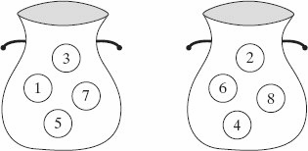
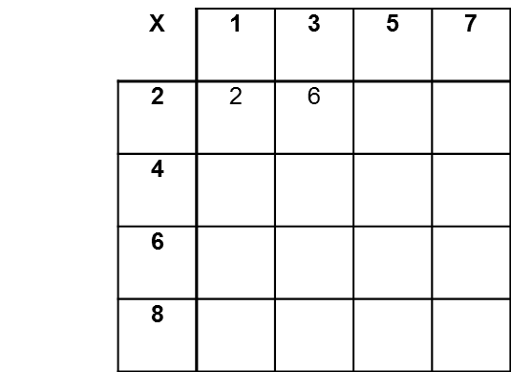
3. Two bags, A and B, each contain four numbered discs that are all the same size.
A disc is drawn at random from bag A and a disc is drawn at random from bag B. A score is obtained by multiplying the numbers on the two discs.
(a) Complete the sample space diagram.
(b) What is the probability of scoring less than 20?
(c) What is the probability of scoring more than more than 18?
Bag B
Bag A
B
A

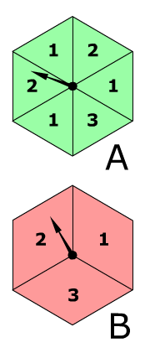

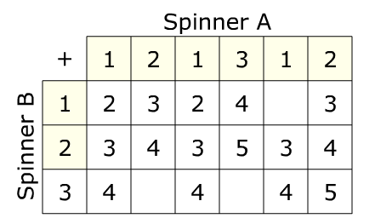












4. Two spinners A and B are spun and the scores are added together.
(a) Complete the sample space diagram.
(b) What is the probability of scoring a total of 2?
(c) What is the probability of getting an even total?
(d) What is the probability of getting a total that is a multiple of 3?

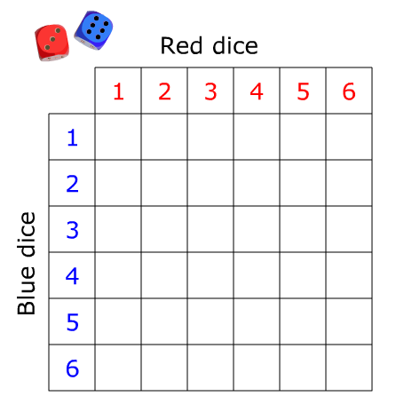


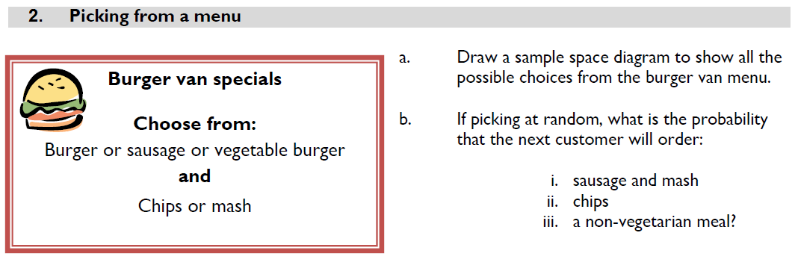
(g) What is the probability of the total score being a prime number?
(h) What is the probability of the total score being a factor of 12?
(f) What is the probability of getting a double (same number on each die)?
(a) Complete the sample space diagram.
1. A blue and a red dice are thrown and the scores added together.
(b) What is the probability of scoring a 4?
(c) What is the probability of scoring a 9?
(d) What is the probability of scoring 10 or more?
(e) What is the probability of scoring 5 or less?
Sample space diagrams

